**Storyboarding for Holy Cheese!**

**Title: *Prologue***

**Summary:**

*The back story of the Holy Cheese.*

**Characters:**

*Swiss Summit Farms and the Mascot Alpina Moo, Clawdius Maximus, the Whiskered Wardens, the Pinktail Posse, Greybeard.*

**Setting:**

*Front gates to Swiss Summit Farm, the Chamber of the Holy Cheese*

**Panels:**

| **Panel #** | **Description** | **Dialogue** |
| --- | --- | --- |
| 1 | Front Gate Scene | Long ago, nestled in the rolling meadows of **Swiss Summit Farms**, a land rich with the purest milk and the happiest cows, a marvel unlike any other was born. Crafted by the hands of master cheesemakers, **Holy Cheese** emerged—a flawless round of Swiss, so perfect that its golden glow was whispered to hold powers beyond mortal understanding. |
| 2 | Enter the Chamber of the Holy Cheese | Legends spread across the land that the cheese contained **a mystical essence**, capable of transforming even the humblest creatures into beings of unimaginable strength and wisdom. It was said that the spirits of the dairy itself had blessed the cheese, ensuring that it would remain pure and undisturbed. But power always draws the eyes of those who seek to twist it for their own gain. |
| 3 | The Whiskered Wardens | To defend this sacred creation, an order of protectors arose—the **Whiskered Wardens of the Majestic Meow**. These feline warriors, swift of paw and sharp of claw, devoted themselves to **an eternal watch** over the Holy Cheese, standing as its first and last line of defense. Through the ages, the Wardens passed their duty from generation to generation, fighting off all who dared trespass on their domain. **For eight lifetimes, they have held the line.** |
| 4 | The Pinktail Posse | Yet, darkness stirs in the underbelly of Swiss Summit Farms. From the shadows, **a menace emerges—the dreaded Pinktail Posse**. A band of cunning, insatiable rats who have gnawed their way through every stronghold in the land, leaving chaos and ruin in their wake. These vermin **do not simply steal—they consume, they transform**. And now, their greedy eyes have fixed upon **the greatest prize of all**: Holy Cheese itself |
| 5 | A battle scene | The Whiskered Wardens, mighty though they are, stand battered and weary. Their numbers have dwindled, and they know the battle ahead will be unlike any before. **Each bite the rats raise new monstrous rats**, twisted by the cheese’s magic into foes of terrifying power. The balance of the land teeters at the edge of disaster, and only one thing is certain—  **The battle for Holy Cheese has begun.** |
|  |  |  |
|  |  |  |
|  |  |  |
|  |  |  |
|  |  |  |
|  |  |  |

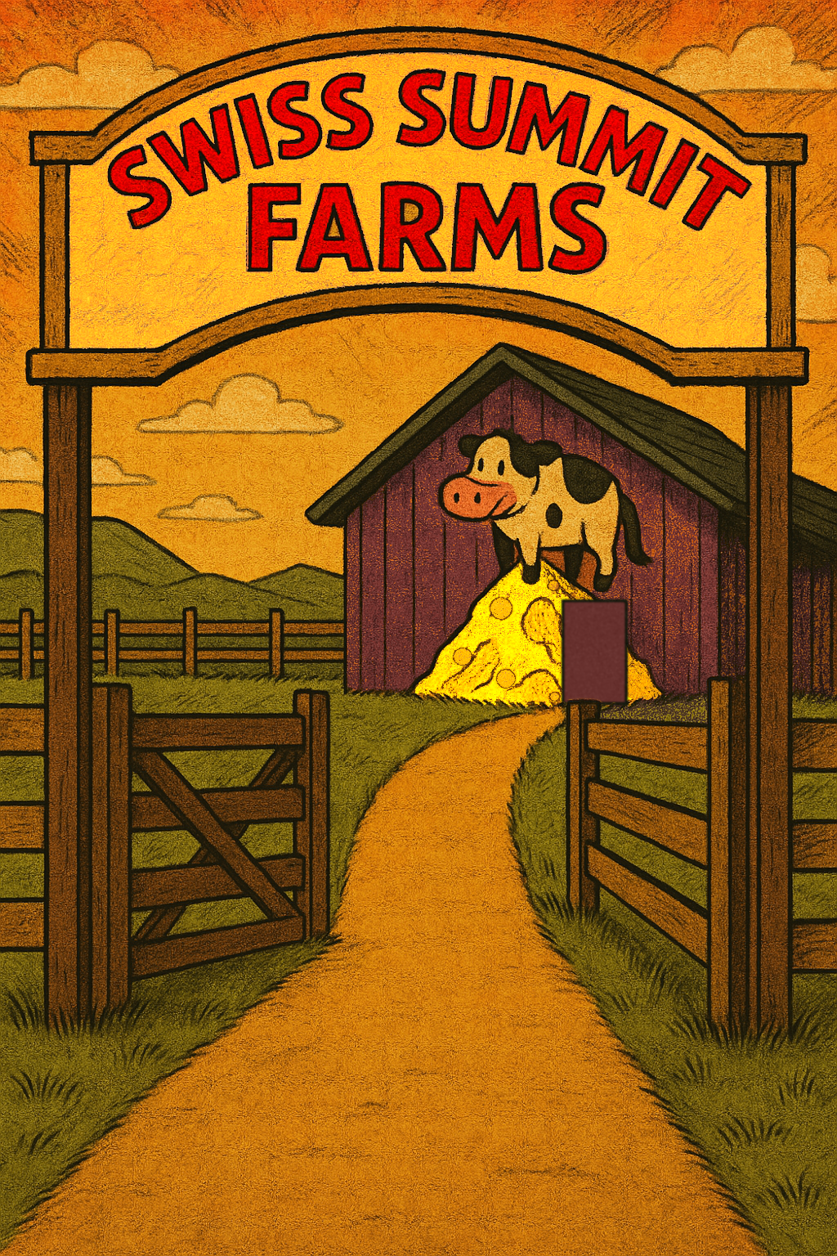

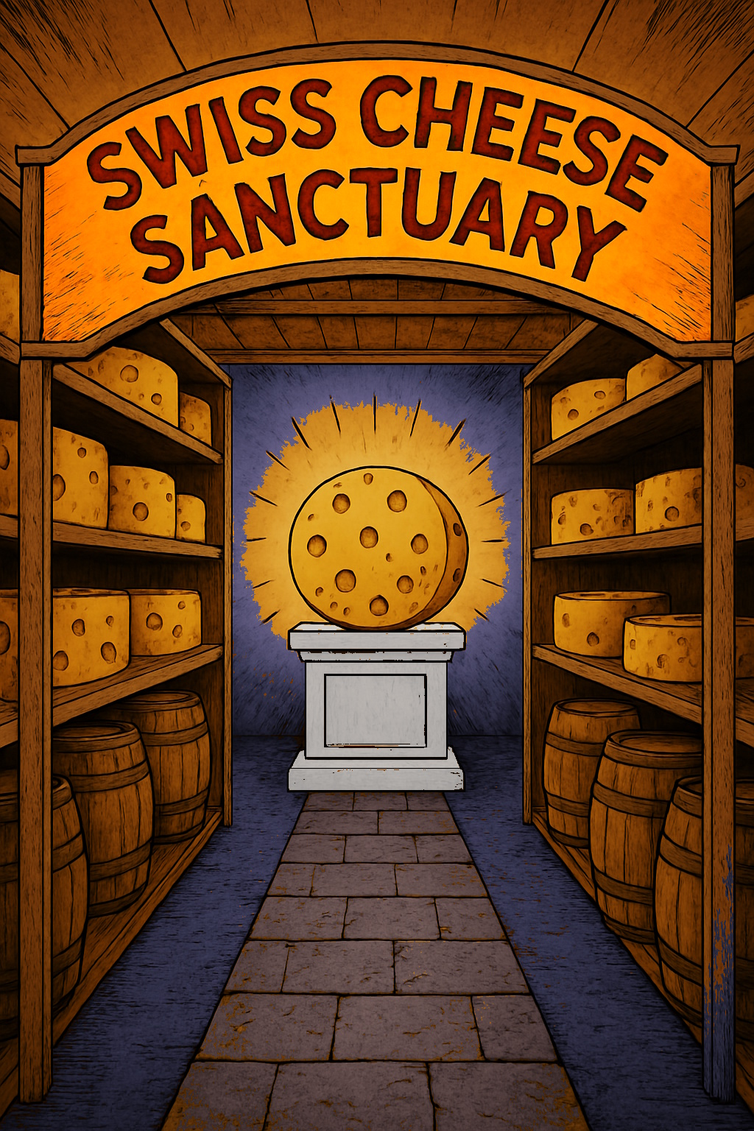

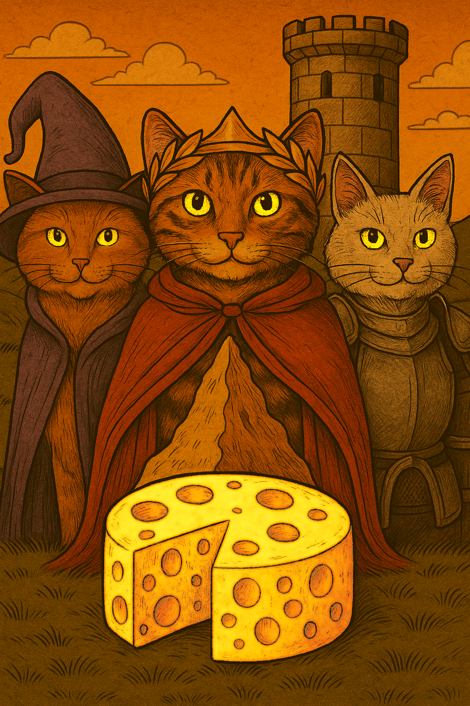

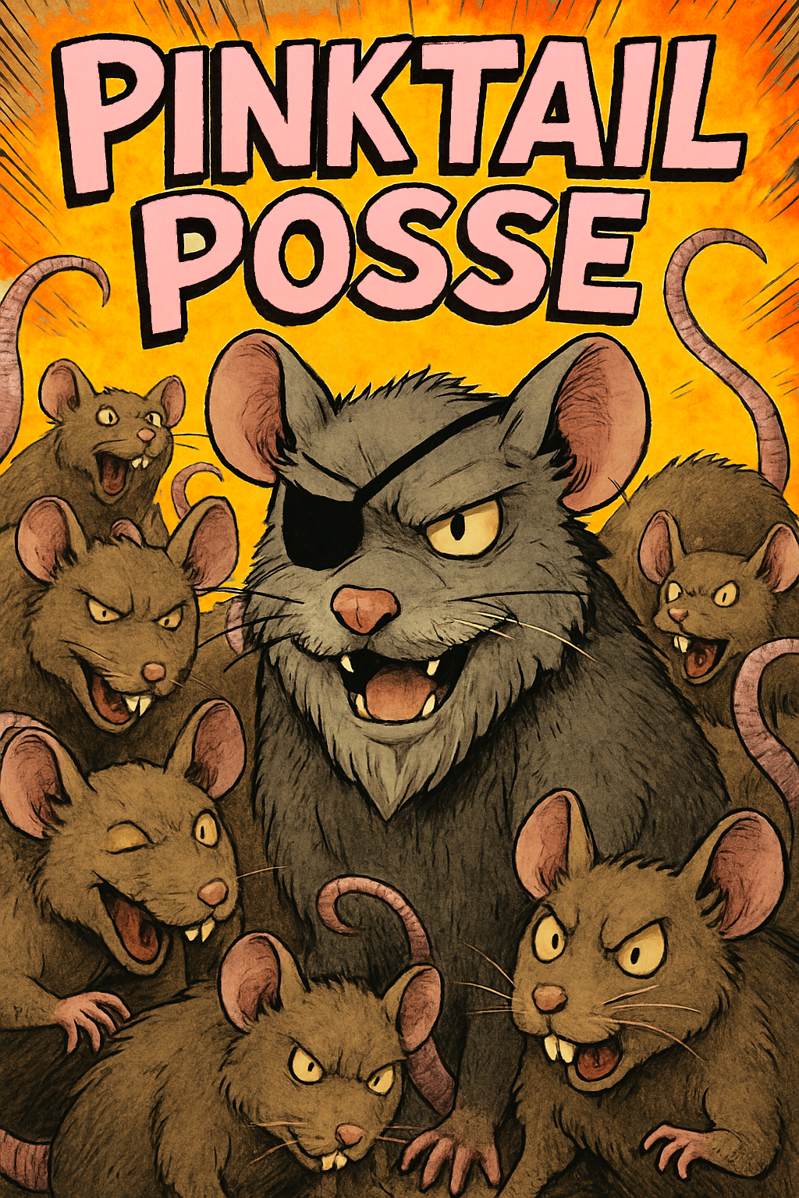

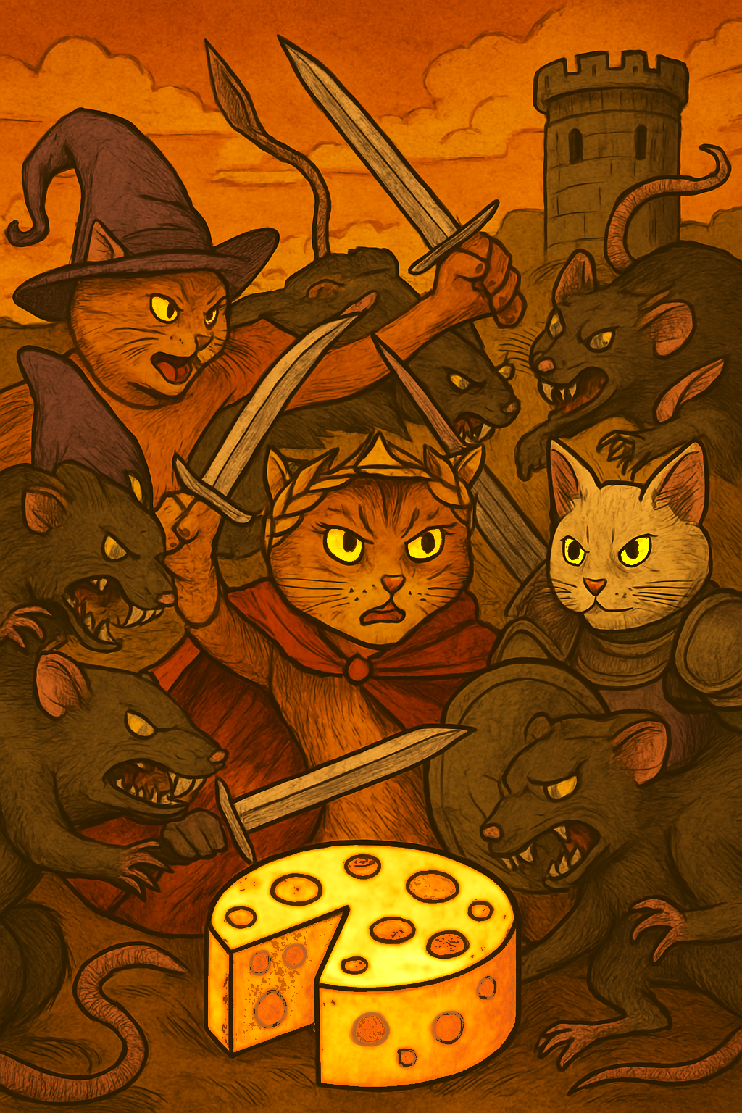

**Title: *Act One: Rodent Reapers Revenge***

**Summary:**

*After level one is finished, the player finds out that the Rodent Reapers, a special squad of the Pinktails, has infiltrated the Holy Cheese Chamber and stolen ¼ of the cheese.*

**Characters:**

*Clawdius Maximus, the Rodent Reapers*

**Setting:**

*The Chamber of the Holy Cheese, a rat hole, the Pinktail home base.*

**Panels:**

| **Panel #** | **Description** | **Dialogue** |
| --- | --- | --- |
| 1 | Holy Cheese Pedestal | The scent of aged Swiss filled the storeroom, rich and comforting—until the moment of horror struck. Standing before the pedestal, the Whiskered Wardens gasped as they saw the Holy Cheese, their sacred charge, marred beyond repair. A quarter of its perfect golden round was missing, gnawed away by unseen thieves. Claw marks of desperation scraped the floor, the remnants of their frantic search. The silence was heavy, broken only by the slow, measured inhale of Clawdius Maximus, his eyes dark with fury. |
| 2 | Rodent Reapers | Through the corridors of Swiss Summit Farms, the **Rodent Reapers** dashed, their wiry bodies straining under the weight of their prize. Five rats carried the stolen chunk aloft, their pink tails whipping through the air as they scurried towards the safety of their hidden burrow. The barn’s wooden beams trembled beneath the chaos of their escape, their tiny, clawed feet clicking against the floor. Behind them, distant cries of alarm rang out—the first signs of the chase. Yet, the rats laughed, their mission nearly complete. |
| 3 | Pinktail hideout | Deep in the shadowed basement of the barn, **the Pinktail Posse reveled** in triumph. Torches flickered against the stone walls as their cheers echoed in the chamber. They had done the impossible, **they had taken the Holy Cheese**! The stolen piece rested atop a makeshift altar, honored like a relic of war. They crowded around it, gnashing their teeth in celebration, their whiskers twitching with anticipation. **Each bite granted them greater power**, turning them into creatures beyond imagination. This was their moment. This was their conquest. |
| 4 | Angry Cats | But above, in the light of the moon, stood the laurel-crowned Warden, his sword raised high. His tail flicked in agitation; his muscles tense beneath his red cloak. **The Holy Cheese would not remain stolen.** His voice cut through the night, a vow that would shake the earth beneath their paws. ***“We fight,”*** he declared, eyes burning with determination. ***“Not one of those vermin will taste another crumb.”*** And with that, the battle for Holy Cheese truly began. |

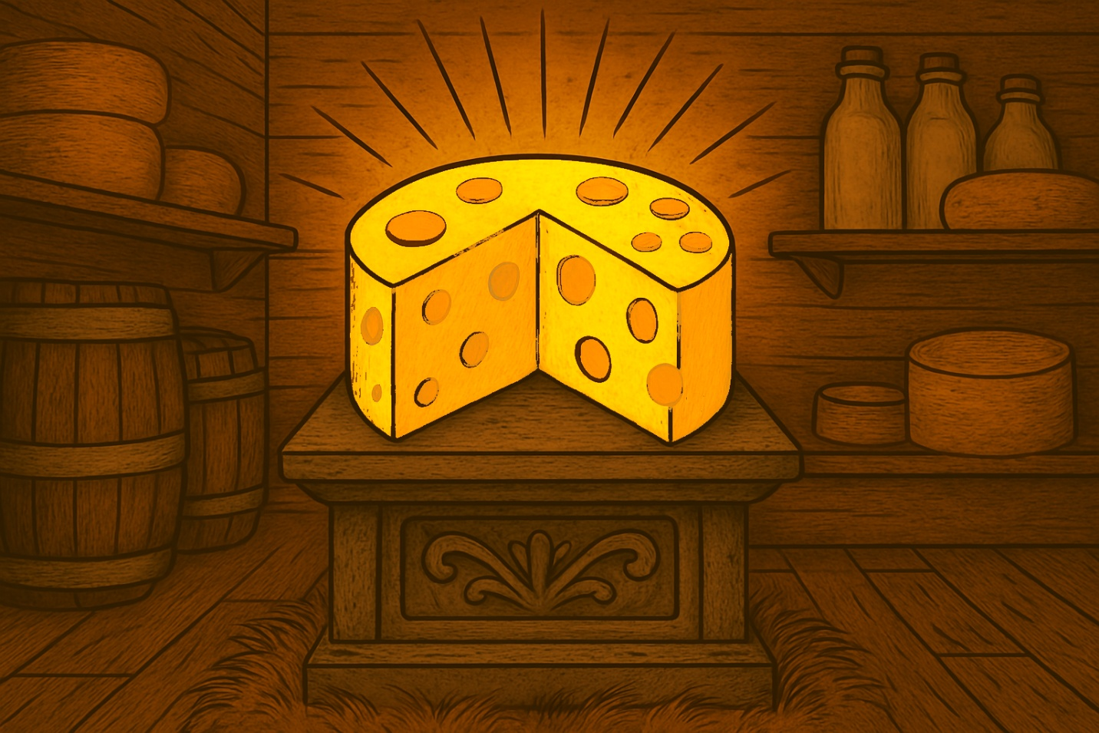

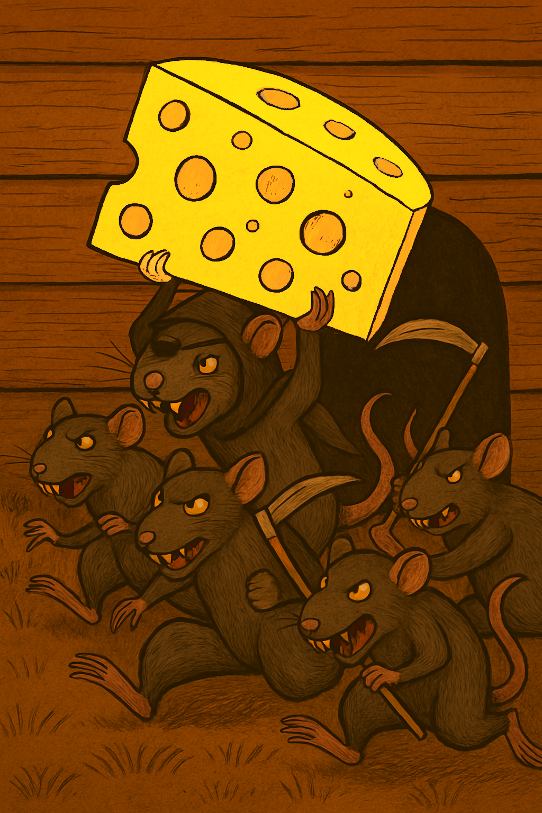

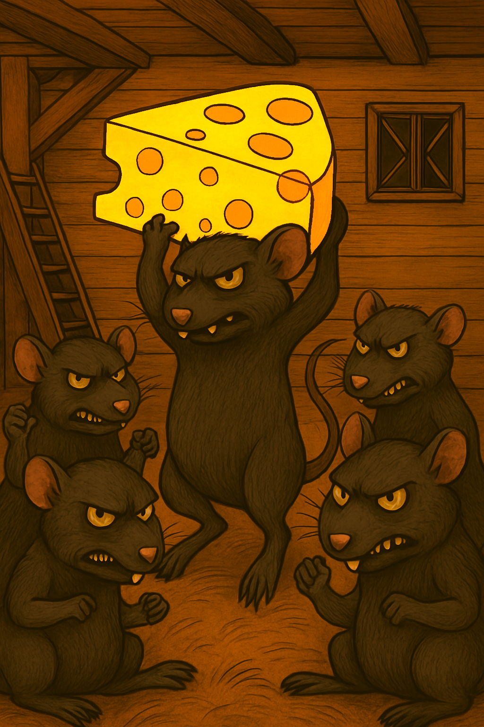

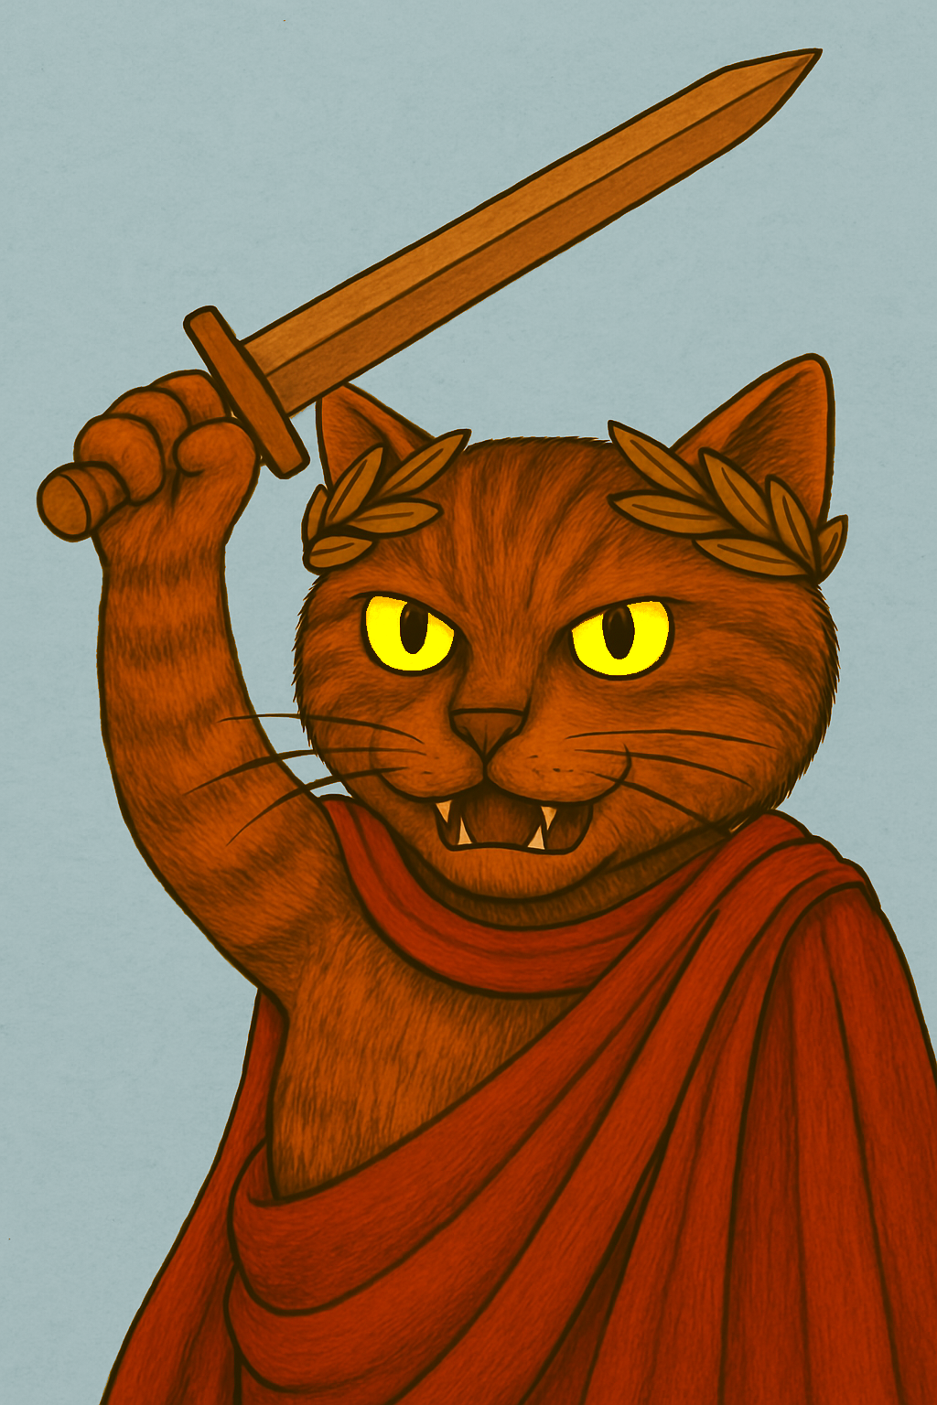

**Title: *Act One: First Mutation***

**Summary:**

*After the first wave of level two is finished, the first mutation of the rats happens and the Titantail is created.*

**Characters:**

*Titantail, wardens*

**Setting:**

Pinktails homebase, the chamber of the Holy Cheese.

**Panels:**

| **Panel #** | **Description** | **Dialogue** |
| --- | --- | --- |
| 1 | Mutation | Deep in the Pinktail Posse’s hideout, under the dim glow of flickering lanterns, a lone rat hoisted a dumbbell above his head. His muscles strained as he lifted, his whiskers twitching with anticipation. He had been chosen for the honor—the first to taste the **Holy Cheese**. As his sharp teeth sank into the stolen wedge, a surge of power rippled through his body. His bones thickened, his fur bristled, and his frame swelled with unstoppable force. His tail elongated into a mighty whip, now lined with ridges of hardened muscle. The transformation was complete—he was no longer just a rat. **He was Titantail.** |
| 2 | Pinktail Posse cheering | The hideout exploded with frenzied cheers. The rats chanted his name, pounding their paws against the cold stone floor. They had witnessed the birth of **their ultimate warrior**, the one who would lead them to victory over the Whiskered Wardens. Some threw scraps into the air in celebration, others ran in circles, too overwhelmed to contain their excitement. Their conquest was no longer just about the cheese—it was about the **power that came with it**. Titantail raised both arms, flexing in the torchlight, casting a shadow so massive it swallowed the room. **The Pinktails had found their champion.** |
| 3 | Titantail standing in front of the Wardens | When Titantail stepped onto the battlefield, the world seemed to shrink beneath him. The storeroom’s wooden beams creaked under his weight as he climbed onto a barrel, standing tall among his fellow rats. His sheer presence sent a ripple of fear through the farm—**he was a titan among vermin**, a force unlike anything Swiss Summit had ever known. His eyes gleamed with wicked ambition as he flexed his enormous arms, letting the power course through him. The Holy Cheese had changed him, and now, he **stood ready to conquer.** The rats gathered around him like loyal soldiers, their pink tails quivering with eagerness. |
| 4 | Wardens looking worried | From the shadows, the **Whiskered Wardens watched**, their pupils wide with dread. Their paws shifted uneasily, their ears flattening against their heads as realization sank in—**this was no ordinary rat**. The laurel-crowned leader gritted his teeth, gripping the hilt of his sword, but even he could not suppress the flicker of uncertainty. Never before had the enemy stood so large, so powerful. A chill ran through the ranks of the feline guardians. **The battle for Holy Cheese had shifted—and the odds were no longer in their favor.** |

